 C5 Programación_Explorador_Virtual_L2

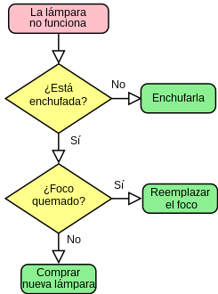*Oscar Ricardo Jurado Zambrano*

*PROFESSOR of ENGLISH: Carlos Moreno*

*Monitora: Dayana hurtado.*

***ACTIVIDAD***

***FORO 1:******Lección 3 Taller: Análisis de sentimientos****.*

*San Juan de Pasto, 23 mayo 2025*

***FORO 1: Lección 3 Taller: Análisis de sentimientos***

***PERSONAL INTRODUCTION***

*Good evening, professor Carlos Moreno.*

*My name is Oscar Ricardo Jurado, and I’m excited to join this python programming course. I’m fifty-two years old, and I have a wonderful son, his name is Samuel Felipe Jurado and he is ten years old. “He is my life”.*

*Respect to my profession, I’m mechanical engineer. I work in the Civil Enginnering program at Mariana University in the San Juan de Pasto city, combining my passion for teaching and enginnering.*

*Beyond my professional life, I’m passionate about learning; I’m fascinated by topics related to mechanical enginnering, extraterrestrial life and time travel. In my free time, I love listening to ballads in both, English and Spanish, as well as the romantic music from the 70’s, 80’s and 90’s. I’m also a movie enthusiast, especially when it comes to science fiction and action films.*

*Science, mathematics and physics are my greatest loves. I believe they are the keys to understanding the universe.*

*I appreciate this opportunity to introduce myself*

*Thank you very much!*

***Activity 1:*** *Cuestionario preguntas de seleccion multiple respecto a la comprensión del siguiente texto.*

***Ada Lovelace***

***THE FIRST COMPUTER PROGRAMMER***

*Ada Lovelace is widely recognized as the world's first computer programmer. She was a British mathematician and writer who, in the 1840s, recognized the potential of Charles Babbage's Analytical Engine beyond pure calculation and developed the first algorithm designed to be carried out by a machine. Her work, including her extensive notes on the Analytical Engine, is considered foundational to computer science. Here's a more detailed look at Ada Lovelace's contributions:****Early Life and Education:****Ada Lovelace was born in 1815 as the only legitimate child of Lord Byron and Annabella Milbanke. Her mother, a mathematician, heavily influenced her education, pushing her towards math and science rather than the arts, which were more common for women of her time.*

***Encounter with Babbage:****At the age of 17, Lovelace met Charles Babbage, a mathematician and inventor, who was working on the Difference Engine and later the Analytical Engine. She became fascinated by the potential of Babbage's machines and their capacity for computation.* ***The Analytical Engine:****Babbage envisioned the Analytical Engine as a general-purpose mechanical computer, capable of not only numerical calculations but also logical operations. Lovelace saw the potential for it to go beyond mere calculations and manipulate symbolic data, which was a vision ahead of its time.*

***Notes on the Analytical Engine:****Lovelace translated an Italian mathematician's article on the Analytical Engine and added extensive notes of her own. These notes included what many consider to be the first algorithm intended to be executed by a machine, a program for calculating Bernoulli numbers*

***Recognition of Computational Potential:***

*Lovelace’s notes highlighted the Analytical Engine’s potential for more than just number crunching, emphasizing its ability to follow a series of instructions to solve problems. She envisioned the engine as a tool for a wide range of tasks, including even composing music.*

***Legacy:***

*Lovelace’s work was largely forgotten until the mid-20th century, when computer scientists rediscovered her notes and recognized their significance. Today, she is celebrated as a pioneer of computer science and is recognized for her foresight in understanding the potential of computing machines. The programming language Ada, developed in the 1970s, is named after her in recognition of the groundbreaking work.*

***CUESTIONARIO.***

*1. Who is widely recognized as the world’s first computer programmer?*

1. *Charles Babbage*
2. *Alan Turing*
3. *Ada Lovelace*
4. *Grace Hopper*

*2. What was Ada Lovelace's nationality?*

1. *American*
2. *French*
3. *British*
4. *German*

*3. What was Ada Lovelace’s father's name?*

1. *Charles Babbage*
2. *Alan Byron*
3. *Lord Byron*
4. *Sir Lovelace*

*4. Who had a strong influence on Ada’s education?*

1. *Her tutor*
2. *Her father*
3. *Her mother*
4. *Charles Babbage*

*5. What field did her mother encourage her to study?*

1. *Art and literature*
2. *Music and dance*
3. *Math and science*
4. *History and philosophy*

*6. What machine did Ada Lovelace write notes about?*

1. *Turing Machine*
2. *Analytical Engine*
3. *ENIAC*
4. *Difference Engine*

*7. Whose article did Ada Lovelace translate and annotate?*

1. *Charles Babbage*
2. *Alan Turing*
3. *An Italian mathematician*
4. *Her tutor*

*8. What mathematical problem was Ada’s algorithm intended to calculate?*

1. *Prime numbers*
2. *Fibonacci sequence*
3. *Pi digits*
4. *Bernoulli numbers*

*9. What did Ada recognize about the Analytical Engine?*

1. *It could only do arithmetic*
2. *It was a poor invention*
3. *It had potential beyond calculation*
4. *It was faster than a human*

*10. What creative use did Ada Lovelace envision for the Analytical Engine?*

1. *Writing novels*
2. *Composing music*
3. *Creating art*
4. *Solving political issues*

*11. When was Ada Lovelace born?*

1. *1825*
2. *1815*
3. *1805*
4. *1835*

*12. What happened to Lovelace’s work after her death?*

1. *It became immediately famous*
2. *It was taught in schools*
3. *It was largely forgotten*
4. *It was published as a book*

*13. When did computer scientists begin to rediscover her work?*

1. *Late 19th century*
2. *Mid-20th century*
3. *Early 21st century*
4. *During her lifetime*

*14. What programming language was named in her honor?*

1. *Python*
2. *Ada*
3. *Lovelace*
4. *Pascal*

*15. Which of the following best describes Ada Lovelace’s legacy?*

1. *She built the first computer*
2. *She invented the internet*
3. *She foresaw computers as general-purpose tools*
4. *She was the first to use binary*

***Activity 2:***

***Instructions:*** *Read each statement carefully. Write* ***True*** *or* ***False*** *on the line provided.*

1. *Ada Lovelace is often considered the world’s first computer programmer.*

*True*

1. *She was born in 1815 and was the daughter of Charles Babbage. False*
2. *Lovelace’s mother encouraged her to study math and science. True*
3. *The Analytical Engine was a machine designed by Ada Lovelace. False*
4. *Lovelace translated a French article and added her own notes. False*
5. *Her notes included what many consider the first algorithm intended for a machine. True*
6. *Ada Lovelace believed the Analytical Engine could only perform mathematical calculations. False*
7. *Lovelace’s contributions were widely recognized during her lifetime. False*
8. *A modern programming language named “Ada” honors her legacy. True*
9. *Lovelace’s work is now seen as foundational to the field of computer science. True*

*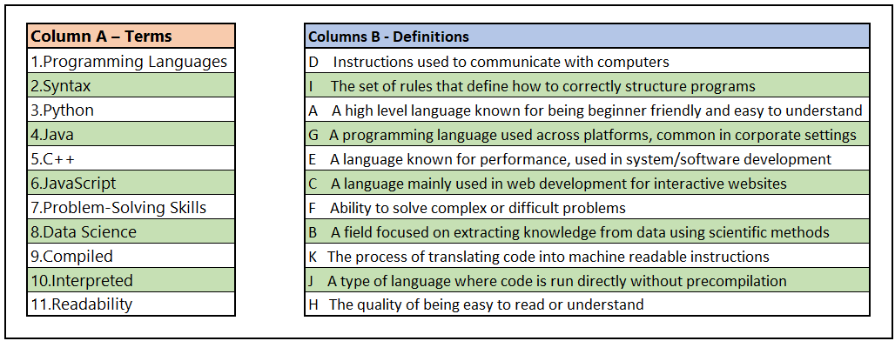****Activity 3: Relacion de columnas conceptos con terminos***

*PASADO VERBOS REGULARES (Pronunciacion como D, como T o como ID)*

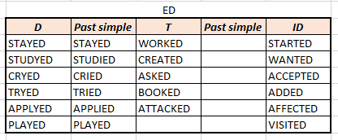

*Vocabulary y Parafraseo:*

*Encounter: An interaction, whether brief or meaningful, with someone or something.*

*Envisioned: To foresee or mentally project how something might look or develop.*

*Mere: Used to emphasize how small or insignificant something is*

*Ahead: Leading or making progress*

*Groundbreaking: Being the first of its kind, leading the way for future developments*

*PROGRAMMING LANGUAGE: It's a formal language that allows instructing a computer to perform specific tasks.*

*Rather: Used to indicate one's preference in a particular matter.*

*Develop: Is the same, that to invent*

*Design: Is the person that create things*

*Step: Instant or part of a thing or activity*